TASK 5

Step 1

Create Git Hub account.

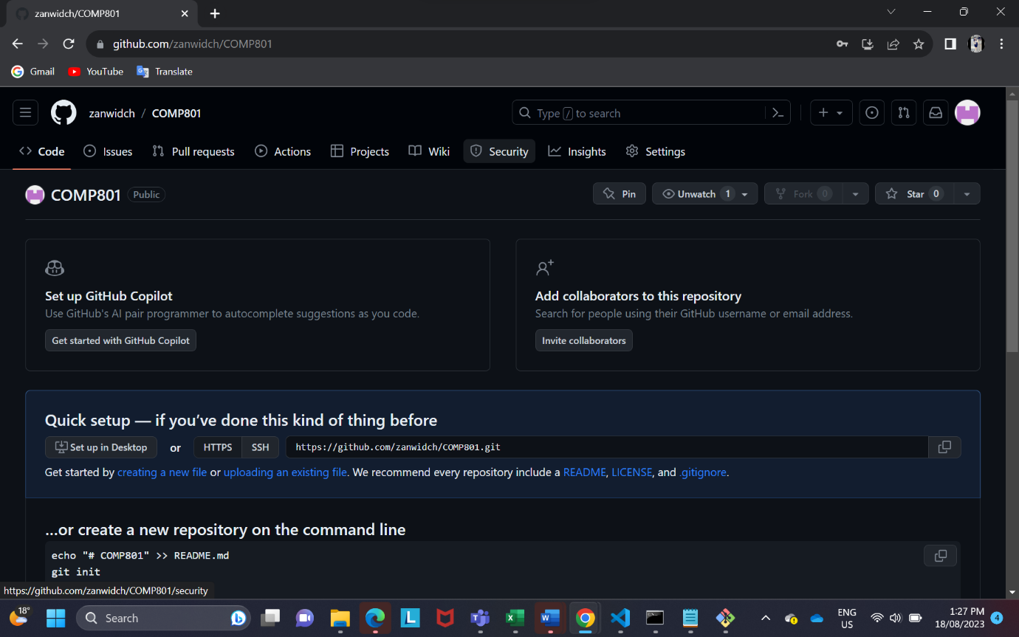

Step 2

Create repository.

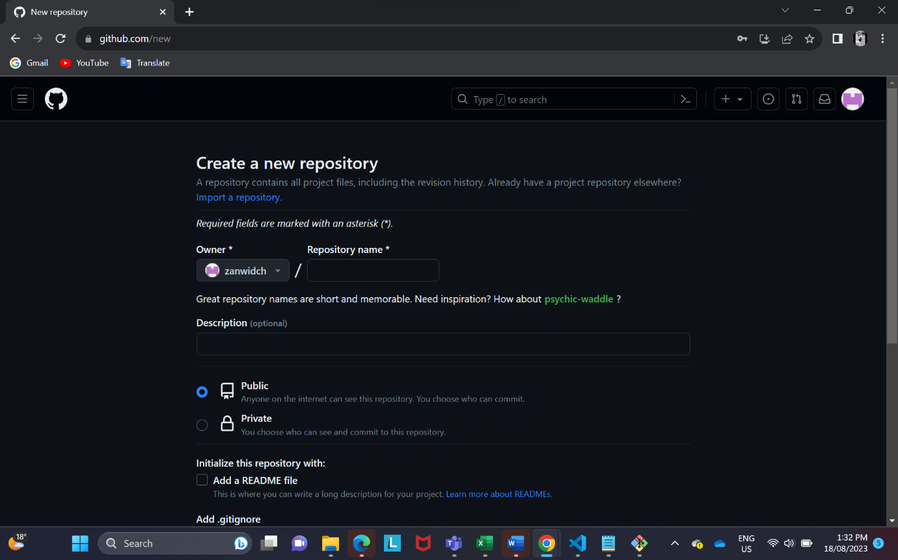

Step 3

Install **Download**the **Git Credential Manager**

<https://github.com/GitCredentialManager/git-credential-manager/releases/tag/v2.0.886>

Step 4

using git bash to clone the repository.

